*Project 1-Serverless image processing*

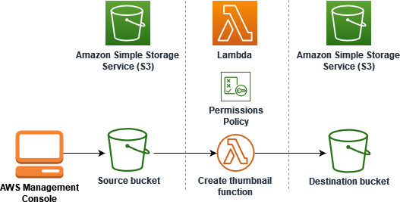

**Step 1-** sign in to your aws account.

# **step 2-**Create two S3 buckets

## 

# **Step 3**-Upload a test image to your source bucket

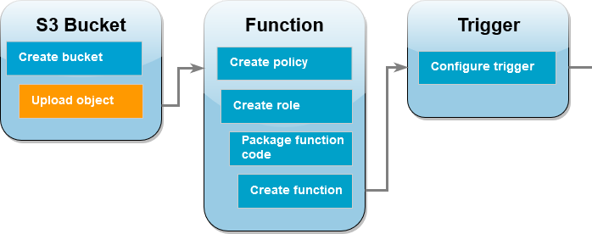

## 

# **Step 4**-Create a permissions policy

## To create the policy (console)

1. Open the [Policies](https://console.aws.amazon.com/iamv2/home#policies) page of the AWS Identity and Access Management (IAM) console.
2. Choose **Create policy**.
3. Choose the **JSON** tab, and then paste the following custom policy into the JSON editor.
4. {
5. "Version": "2012-10-17",
6. "Statement": [

7. {

1. "Effect": "Allow",
2. "Action": [
3. "logs:PutLogEvents",
4. "logs:CreateLogGroup",
5. "logs:CreateLogStream"

13. ],

14. "Resource": "arn:aws:logs:*:*:*"

15. },

16. {

1. "Effect": "Allow",
2. "Action": [
3. "s3:GetObject"

20. ],

21. "Resource": "arn:aws:s3:::msmainbucket/*"

22. },

23. {

1. "Effect": "Allow",
2. "Action": [
3. "s3:PutObject"

27. ],

28. "Resource": "arn:aws:s3:::msresizebucket/*"

29. }

30. ]

}

1. Choose **Next**.
2. Under **Policy details**, for **Policy name**, enter ***resizepolicy.***
3. Choose **Create policy**.

**Step 5-**Create an execution role

## To create an execution role and attach your permissions policy (console)

1. Open the [Roles](https://console.aws.amazon.com/iamv2/home#roles) page of the (IAM) console.
2. Choose **Create role**.
3. select **AWS service**, and for **Use case**, select **Lambda**.
4. Choose **Next**.
5. Add the permissions policy you created in the previous step by doing the following:
   1. In the policy search box, enter ***resize policy*** and choose it.
   2. Choose **Next**.
6. Under **Role details**, for the **Role name** enter ***resizerole.***
7. Choose **Create role**.

# **Step 6-**Create the function deployment package

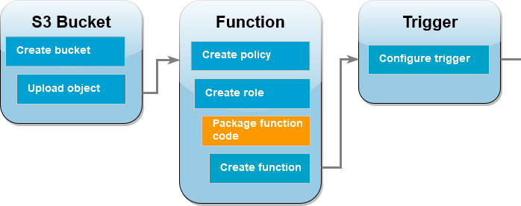

1. We create function.zip file.

**Step 7-**Create the Lambda function

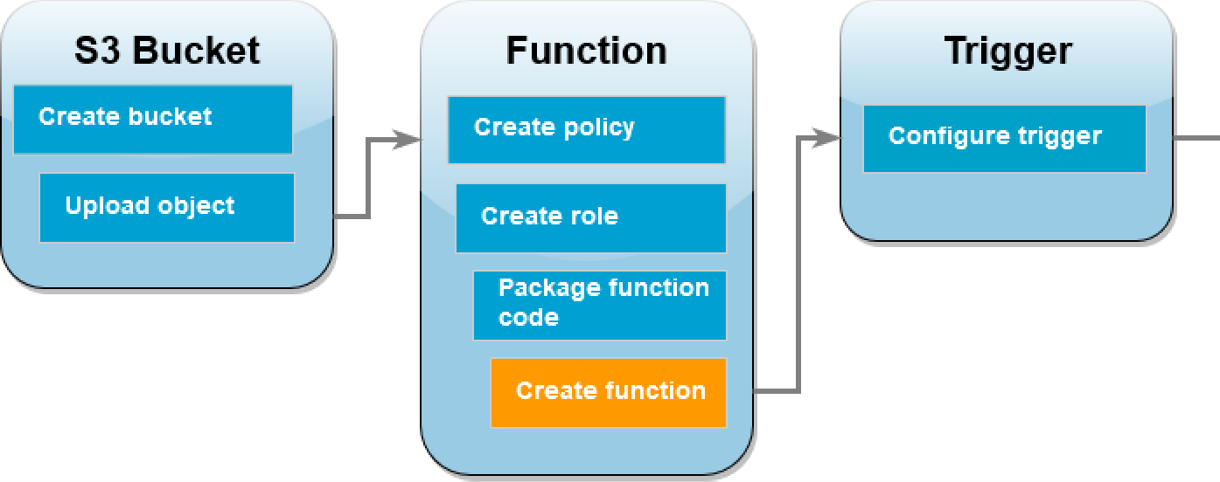

**To create the function (console)**

1. 1. Open the [Functions page](https://console.aws.amazon.com/lambda/home%23/functions) of the Lambda console.
2. 2. Choose **Create function**.
3. 3. Choose **Author from scratch**.
4. 4. Under **Basic information**, do the following:
   1. 5. For **Function name**, enter **resizelambda**.
   2. 6. For **Runtime**choose either **Node.js 18.x** .
   3. 7. For **Architecture**, choose **x86_64**.
5. 8. In the **Change default execution role** tab, do the following:
   1. 9. Expand the tab, then choose **Use an existing role**.
   2. 10. Select the ***resizerole*** you created earlier.
6. 11. Choose **Create function**.

# **Step 8-**To upload the function code (console)

1. 1. In the **Code source** pane, choose **Upload from**.
2. 2. Choose **.zip file**.
3. 3. Choose **Upload**.
4. 4. In the file selector, select your .zip file and choose **Open**.
5. 5. Choose **Save**.

**Step 9-**Configure Amazon S3 to invoke the function

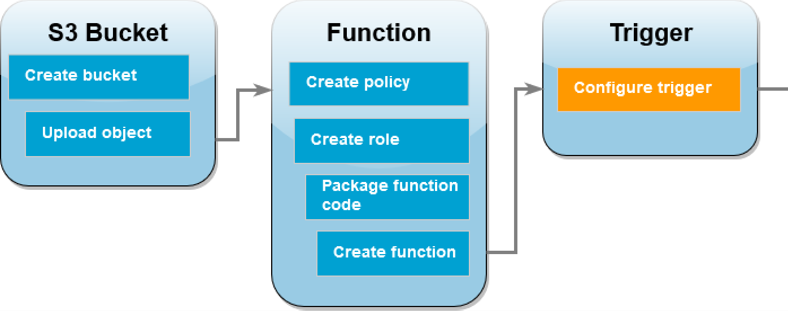

**To configure the Amazon S3 trigger (console)**

* 1. Open the [Functions page](https://console.aws.amazon.com/lambda/home%23/functions) of the Lambda console and choose your function (CreateThumbnail).
  2. Choose **Add trigger**.
  3. Select **S3**.
  4. Under **Bucket**, select your source bucket.
  5. Set all options are as default.
  6. Choose **save**.

**Test your Lambda function with a dummy event**

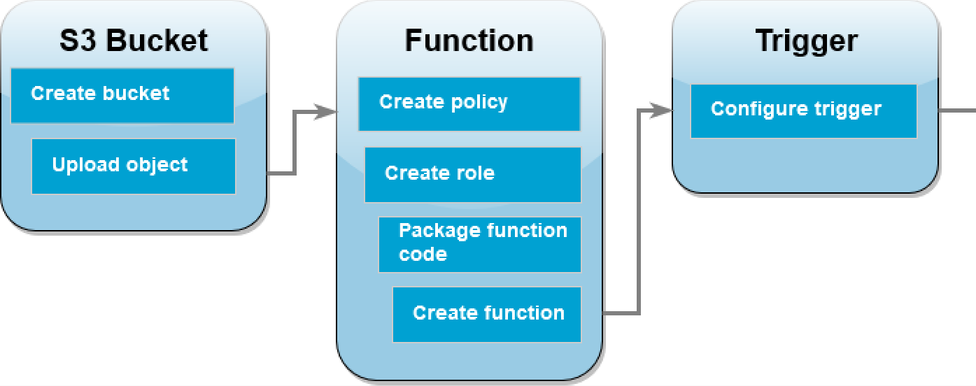**To test your Lambda function with a dummy event (console)**

* + - Open the [Functions page](https://console.aws.amazon.com/lambda/home%23/functions) of the Lambda console and choose your function (resizelambda).
    - Choose the **Test** tab.
    - To create your test event, in the **Test event** pane, do the following:
      * Under **Test event action**, select **Create new event**.
      * For **Template**, select **S3 Put**.
      * Replace the values for the following parameters with your own values.
        + For awsRegion, replace us-east-1 with the AWS Region you created your Amazon S3 buckets in.
        + For name, replace DOC-EXAMPLE-BUCKET with the name of your own Amazon S3 source bucket.
        + For key, replace test%2Fkey with the filename of the test object you uploaded to your source bucket in the step [Upload a test image to your](https://docs.aws.amazon.com/lambda/latest/dg/with-s3-tutorial.html#with-s3-tutorial-test-image) [source bucket](https://docs.aws.amazon.com/lambda/latest/dg/with-s3-tutorial.html#with-s3-tutorial-test-image).

a. "Records": [

b.

{

c.

"eventVersion": "2.0",

d.

"eventSource": "aws:s3",

e.

"awsRegion": *"south-ap-1"*,

1. "eventTime": "1970-01-01T00:00:00.000Z",
2. "eventName": "ObjectCreated:Put",
3. "userIdentity": {
4. "principalId": "EXAMPLE"
5. },
6. "requestParameters": {
7. "sourceIPAddress": "127.0.0.1"
8. },
9. "responseElements": {
10. "x-amz-request-id": "EXAMPLE123456789",
11. "x-amz-id-2": "EXAMPLE123/5678abcdefghijklambdaisawesome/mnopqrstuvwxyzABCDEFGH"
12. },
13. "s3": {
14. "s3SchemaVersion": "1.0",
15. "configurationId": "testConfigRule",
16. "bucket": {
17. "name": *"msmainbucket"*,
18. "ownerIdentity": {
19. "principalId": "EXAMPLE"
20. },
21. "arn": "arn:aws:s3:::msmainbucket "
22. },
23. "object": {

|  |  |  |  |  |  |
| --- | --- | --- | --- | --- | --- |
| cc. |  |  |  |  | "key": *"SampleJPGImage_100kbmb.jpg"*, |
| dd. |  |  |  |  | "size": 1024, |
| ee. |  |  |  |  | "eTag": "0123456789abcdef0123456789abcdef", |
| ff.  gg.  hh.  ii.  jj. | ] | } | } | } | "sequencer": "0A1B2C3D4E5F678901" |

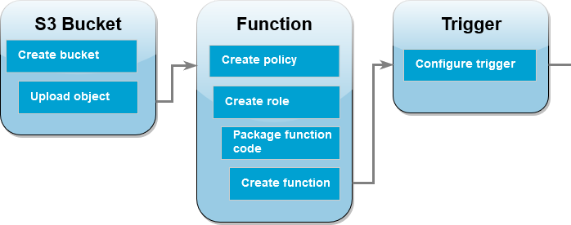

**To test your Lambda function using the Amazon S3 trigger (console)**

}

* Choose **Save**.
* In the **Test event** pane, choose **Test**.
* To check the your function has created a resized verison of your image and stored it in your target Amazon S3 bucket, do the following:
  + Open the [Buckets page](https://console.aws.amazon.com/s3/buckets) of the Amazon S3 console.
  + Choose your target bucket and confirm that your resized file is listed in the **Objects** pane.

**Step 10-**Test your function using the Amazon S3 trigger

1. To upload an image to your Amazon S3 bucket, do the following:
2. Open the [Buckets](https://console.aws.amazon.com/s3/buckets) page of the Amazon S3 console and choose your source bucket.
3. Choose **Upload**.
4. Choose **Add files** and use the file selector to choose the image file you want to upload. Your image object can be any .jpg or .png file.
5. Choose **Open**, then choose **Upload**.
6. Verify that Lambda has saved a resized version of your image file in your target bucket by doing the following:
7. Navigate back to the [Buckets](https://console.aws.amazon.com/s3/buckets) page of the Amazon S3 console and choose your destination bucket.
8. In the **Objects** pane, you should now see two resized image files, one from each test of your Lambda function. To download your resized image, select the file, then

choose **Download**.